**Info for Yanni’s family & Finest evoo**

1. **Our family**

Our olive groves, our facilities and our whole life are rooted in Chalkidiki, and especially in the small seaside town of Nea Potidea. The town is surrounded on three sides by the sea and has an altitude of 20m. It is situated at the entrance of the peninsula of Kassandra and boosts a rich history. It is a wonderful place where we live and raise our two children, teaching them to love nature, the earth, and its fruits.

Yanni himself inherited this olive tree farming love from his father Nikos, who first planted the olive trees only with the best olive tree varieties of Chalkidiki.

Our company produces evoos of the highest quality and our vision is to advocate our country’s rich food tradition by producing entirely natural products of especially high quality, rich in beneficial ingredients, which contribute to human health.

Our family believes that your family deserves only the best !

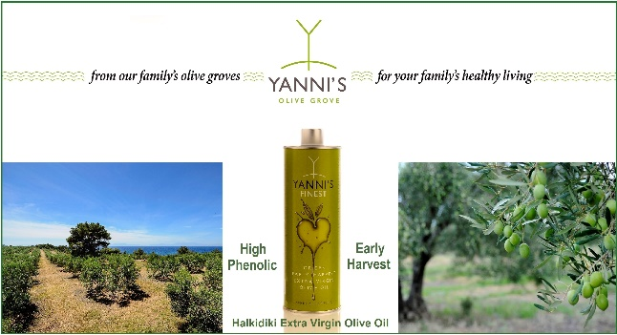

1. **Production**:

In our groves one can find only the local olive tree varieties of Chalkidiki. The most popular ones are CHONDROELIA and GALANI. The know-how and the tradition we have inherited from the elders however, led us to the decision to cultivate the variety of CHONDROELIA grafted into the WILD olive tree of Chalkidiki. This resulted in an excellent product, an extra virgin olive oil with very unique and bold features.

Furthermore, the whole growing process is under the guidance of the KRINOS Olive Center of American Farm School of Thessaloniki.

**Certification**

We strongly believe that in order to produce extra virgin olive oil of the highest quality, one needs a deep knowledge of the tradition of one’s land. Yet, products of excellent quality such as ours, also require the guidance of science and up-to-date technology.

For this reason, we maintain a close cooperation with specialists from universities and accredited laboratories, who study the needs of our trees in nutrients and have integrated all of our olive groves (total of 6500 trees) in an integrated management system. Together, we apply regular organoleptic and chemical analyses on all products at frequent intervals in order to be able to control the quality at all times, while university studies enable us to monitor the sustainability of our green early harvest extra virgin olive oil and extra virgin olive oils.

Moreover, our production process is ISO 22000:2018 certified.

**Selection / Harvest**

Harvesting begins on 15 - 20th of September and is done exclusively by hand in order to avoid any damage to the olive fruit, which could consequently cause its degradation, because of the oxidation.

Our olives are then transported, within a few hours, in ventilated plastic crates of 20-22kg capacity. They are carefully picked out by hand, one by one, so that only the flawless ones will be transferred again in large ventilated, plastic bins of 400kg capacity, to the mill for olive oil extraction.

The olives arrive there only within a few hours from their harvesting, on the very same day, which we consider to be essential for the maintenance of the freshness of our green early harvest extra virgin olive oil.

**Extraction / standardization of extra virgin olive oil (EVOO)**

For the purpose of maintaining its aroma, flavor and the maximum of its functional ingredients, our green early harvest extra virgin olive oil is extracted in a two – phase mill at 22 degrees C. The malaxation is done at a slow speed in no longer than 25 minutes, to avoid formation of emulsions.

The produced green early harvest extra virgin olive oil is then immediately transferred to stainless steel tanks with automatically controlled storage temperature at 16 C and continuous nitrogen flow to avoid oxidation.

The company's bottling is just around the olive groves and is certified by EL 40347. In these ideal conditions the green early harvest extra virgin olive oils of CHALKIDIKI remain fresh until the last drop.

Video production process : [complimentary extra virgin olive oi video](https://www.youtube.com/watch?v=lL7qaVFjkmo)

**Traceability**:

The tradition of olive growing is matched with modern practices and respect for the environment. Our belief is that it is also essential that the consumer will be able to learn about the whole process of creating the final product before he or she picks it from the shelf. For this reason, our company YANNI'S OLIVE GROVE organized and adopted the product’s traceability table which makes it very simple to follow the product’s “journey” from the tree to the shelf or the table. Using a LOT NUMBER which can be seen on the outer package, one can immediately trace out the exact field of origin of the product, as well as information about the mill, the bottling process and generally the whole production chain, and the technical data of it.

You may begin your journey !

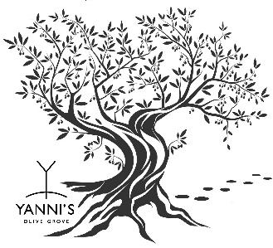 

1. **Yanni’s Corporate Social Responsibility**

YANNI'S OLIVE GROVE as a responsible "citizen" towards the society, but also as a living cell of a wider group, proves its interest and sensitivity in terms of respect for human values, society, the development of science and the protection of the environment.

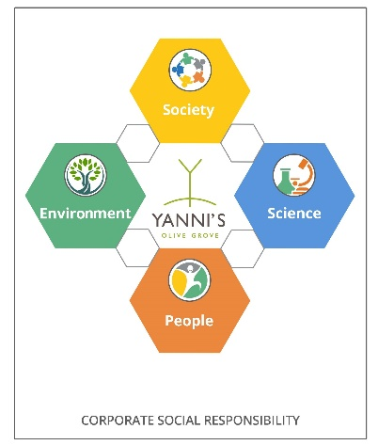

* **PEOPLE**

The search for good life quality is something ancient for humans. The company YANNI’S OLIVE GROVE through innovative actions gives to more people the opportunity to access high quality products, and at the same time tries to offer the necessary knowledge, for them to choose their food products.

Traceability:

Respecting the consumer, we believe that he needs to know, how the production was made and where the product he is going to buy comes from. For this reason, our company has QR CODE on the final packaging, so that the consumer can immediately see the entire course of the product process through the LOT NUMBER directly from the field to the shelf.

Gaiasense for the economy:

Our olive groves applied, as the first and only pilot cultivation from 2016 - 2019, a new pioneering for Greece and Europe three-year program called Intelligent Agriculture (Gaiasense), which was organized in collaboration with the Greek national body GAIA BUSINESS and Neuropublic company.

One of the goals of this program was to reduce production costs, which enabled the wider distribution of the product at a reduced price to the buying public and especially to the vulnerable groups of the Greek population.

This special cultivation program continues to be implemented today by the company YANNI’S OLIVE GROVE, but at the same time it is given by the Greek institution bodies for use to all Greek olive growers

* **ENVIRONMENT**

The quality of the natural environment is the key factor for the "well-being" of the individual and for this reason, the company YANNI’S OLIVE GROVE through innovative actions has as its main axis its protection.

Gaiasense for environmental protection:

One of the goals of this program was to maximize environmental protection through controlled irrigation, fertilization, and plant protection of the olive groves, and to increase the quality of the product.

KRINOS Olive Center of the American Farm School:

The conditions of cultivation, harvesting and standardization of our company are under the care of the " KRINOS Olive Center of the American Farm School". Through special holistic programs and the scientific guidance of the " KRINOS Olive Center" we manage to achieve top-quality products every year, based on the absolute protection of the environment.

* **SOCIETY**

According to the President of the Panhellenic Federation of Alzheimer's Disease and Related Disorders, Professor M. M. Tsolaki (Neurologist, Psychiatrist, Theologist):

"Alzheimer's disease was first described in 1906 by the German psychiatrist and neuropathologist A. Alzheimer. This disease destroys the - navigation system of man in space and time - and has a very large number of patients.

The YANNI’S OLIVE GROVE team stands by these patients because we believe that they should “keep making memories”.

Panhellenic Federation of Alzheimer's Disease and Related Disorders: YANNI'S OLIVE GROVE supports the Federation's goals in all its scientific, social, and philanthropic activities, through its General Managing Director E. Psounou, who has the honors to serve as General Secretary of the Federation's Board. <http://www.alzheimer-federation.gr/index.php/about-us>

PANHELLENIC INSTITUTE OF NEURODEGENERATIVE DISEASES**:**  YANNI’S OLIVE GROVE as an official sponsor supports the aims of the Institute in all its scientific, social, and charitable activities. <http://www.pindis.gr/>

Greek Association of Alzheimer’s Disease and Related Disorders (Alzheimer Hellas): YANNI’S OLIVE GROVE as an official sponsor supports the purposes of ALZHEIMER HELLAS in every scientific, social, and charitable event. <http://www.alzheimer-hellas.gr/index.php/el/home/aboutus>

* **SCIENCE**

Today in Greece, more than 197,000 people are ill with Alzheimer's disease, with the prospect this number to launch in 354,000 in 2050, according to the president of the Panhellenic Federation of Alzheimer's Disease and Related Disorders, Professor M. Tsolaki (Neurologist, Psychologist, Theologist).

Considering the words that Hippocrates from Kos (460 - 377 BC), the father of medical science, said: "Our food is our medicine, and our medicine is our food", the philosophy of our company was formed based on the Mediterranean diet as our main approach to human health. With innovative steps in collaboration with the scientific community, our purpose is to offer a non-pharmaceutical and economical approach to Alzheimer's patients.

**MICOIL is a nature’s gift to man**!

Yanni’s Finest EVOO is the first Greek EVOO applied on many certified scientific clinical trials on humans showing its health benefits by supporting the physiological human function.

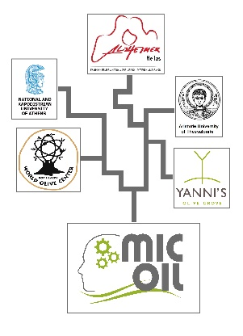

The MICOIL’s multy paper study partners were “The Greek Association of Alzheimer’s Disease and Related Disorders - Alzheimer Hellas”, “the World Olive Center for Health -WOCH” the “Aristotle University of Thessaloniki in Greece” the “National Kapodistrian University in Athens” and the olive oil production company “Yanni’s Olive Grove”.

The first papers of the study have recently been published in major medical journals proving that:

**MASTER STUDY: A randomized clinical trial of Greek High Phenolic Early Harvest Extra Virgin Olive Oil in Mild Cognitive Impairment: the MICOIL pilot study.**

(Magda Tsolaki, Eftychia Lazarou, Machi Kozori, Niki Petridou, Irene Tabakis , Ioulietta Lazarou, Maria Karakota, Iordanis Saoulidis, Eleni Melliou and Prokopios Magiatis, 2020).

**Results:** A long-term intervention with Yanni’s Finest early- harvest extra virgin olive oil was associated with a significant improvement in cognitive function compared to the Mediterranean diet. The Principal Investigator of the MICOIL study/ Professor of 1st Department of Neurology, Aristotle University of Thessaloniki, Greece /and Chair of Greek Federation of Alzheimer’s disease in Greece, Prof. Magda Tsolaki said “To date, there is no other study that has examined in such detail the effects of extra virgin olive oil on the elderly with Mild Cognitive Impairment as an effective solution for cognitive impairment”

**Publications:**

* + JAD’s Official press release : <https://www.j-alz.com/content/randomized-clinical-trial-greek-high-phenolic-early-harvest-extra-virgin-olive-oil-mild>
  + Journal of Alzheimer's Disease (JAD): <https://pubmed.ncbi.nlm.nih.gov/33044178/>
  + IOS PRESS: <https://content.iospress.com/articles/journal-of-alzheimers-disease/jad200405>

**2nd study: Administration of the extra virgin olive oil (EVOO) in mild cognitive impairment (MCI) patients as a therapy for preventing the progress to AD.**

(Tzekaki E. Eleni, 2019)

**Results:** The levels of the oxidative stress biomarker, malondialdehyde (MDA) showed a significant decrease in MCI patients subjected to EVOO therapy revealing the involvement of the beneficial antioxidative properties of EVOO in the progression of AD.

**Publications:**

* + Journal of Alzheimer's Disease: <https://pubmed.ncbi.nlm.nih.gov/31802059/>
  + Awarded with the second prize by the **5th International Medical Olympiad** in 2019 <https://www.nuclmed.gr/issue/supplement-3/> PAGE 181

**3rd Study: Polar phenols of virgin olive oil : an estimate of their content in commercial products to be used in a clinical study to prevent Mild Cognitive Impairment.**

(Prodromou I. Sofia, 2020)

**Results:** It is showed that the cultivation and harvest process are in excellent level using online satellite and meteorological data systems. During the olive oil milling either with laboratory or industrial practices the product of Yanni’s early harvest evoo shows a major phenolic content and also can preserve its high phenolic content it in time.

**Publications:**

* + Aristotle University of Thessaloniki: <https://search.lib.auth.gr/Record/1116660?lng=en>

**4th Study: Restoration of BMI1 levels after the administration of early harvest extra virgin olive oil as a therapeutic strategy against Alzheimer’s disease.**

(Elena E. Tzekaki, Angelos Papaspyropoulos, Magda Tsolaki, Eftychia Lazarou, Mahi Kozori and Anastasia A. Pantazaki, 2020)

**Results:** The study implies that EVOO, a completely natural product, may potentially act as an alternative therapy for preventing AD onset. Restoration of BMI1 activity by the proposed one year supplementation could represent a therapeutic modality for AD, hence having an important impact on the design of future therapeutic strategies for AD prevention.

**Publications:**

* + Experimental Gerontology (2020) <https://www.sciencedirect.com/science/article/abs/pii/S053155652030526X?via%3Dihub>

Three more MICOIL’s paper studies ready to be published soon and one more for Breast Cancer.

We shall keep you informed.